Information on ISLS 2021 Symposium

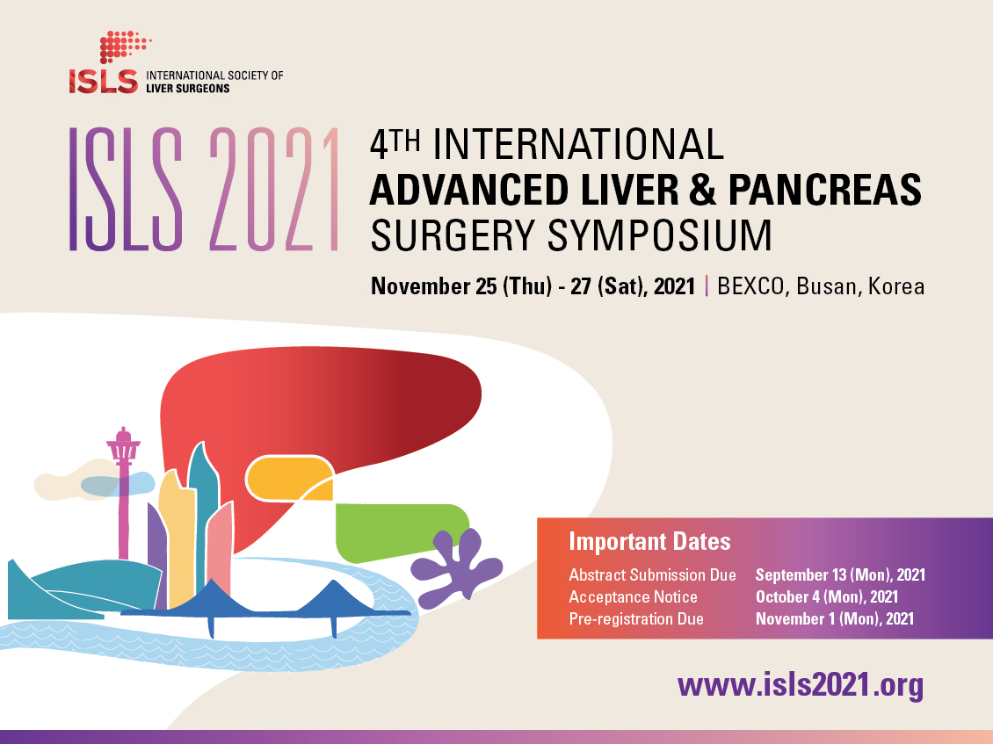

First of all, on behalf of the organizing committee, we would like to express our sincere gratitude for your continuing support and interest in The 4th International Advanced Liver & pancreas Surgery Symposium (ISLS 2021 Symposium) hosted by the International Society for Liver Surgeons (ISLS).

We have been monitoring the COVID-19 pandemic closely over the past months in an effort to respond appropriately to the situation for your safe participation and the smooth management of the symposium. With increasing travel restrictions and the uncertainty of worldwide participation, we have decided to postpone the symposium to November 25-27, 2021 from July 1-3, 2021.

Accordingly, the due dates for abstract submissions and pre-registration have also been adjusted. Please re-mark your calendar and ask for your continuing support and interest.

ISLS 2021 Symposium is planning a Live Demonstration Session featuring a living donor liver transplantation on the first day, not to mention diverse symposiums that will bring together eminent speakers and delegates from all over the world. Participants will have the chance to hear them debate on practical issues encountered in the clinical field, the latest surgical techniques, and the most up-to-date research results and accomplishments in the field of hepato-biliary-pancreatic and transplant surgery.

ISLS 2021 Symposium plans to offer a variety of awards and travel grants for participants who submit abstracts to the symposium. It would be a great chance to not only share your research with experts from all around the world, but also receive recognition for your achievements in the form of an award or travel grant.

- Overview
- Title: The 4th International Advanced Liver & Pancreas Surgery Symposium (ISLS 2021 Symposium)
- Date: November 25-27, 2021
- Venue: BEXCO, Busan, Korea
- Official Language: English
- Hosted by: International Society of Liver Surgeons (ISLS)
- Website: http://www.isls2021.org
- New Important Dates:
Abstract Submission Due Date: September 13 (Mon), 2021
Pre-registration Due Date: November 1 (Mon), 2021

- Online Abstract Submission
Online Abstract Submission is now open! We invite you to submit your abstract for Oral or E-poster Presentation. For more information including topics and guidelines, please click here.

- Travel Grants
The ISLS 2021 Symposium organizing committee will provide travel grants to foreign presenting authors whose abstracts are selected for Oral or E-poster Presentation. The grant will be USD 1,000 up to 1,500 each in accordance with our regulations based on the distance from the country of residence of the presenting author to Korea. For more details on the regulations, please click here.

